-Paper-

TYPE THE TITLE OF YOUR PAPER, ALL CAPITALIZED.

AUTHOR NAME^{a,*}, AUTHOR NAME^{b}, and AUTHOR NAME^{c}

ªDepartment of Science, Xxxxx University, 1-2-3 Xxxxx, Xxxxx 123-0012, Japan
^{b}Faculty of Natural Science , Xxxxx University, 2-3-4 Xxxx, Xxxx 234-0055, Japan
^{c}National Institute of Technology , 1-1-1 Xxxx, Xxxx 356-0001, Japan

Running title: Short title of the manuscript
Title and full names are in all capital letters and centered on the page. The corresponding author is identified with asterisks (*). If the authors have more than one affiliation, superscript alphabets should be used to indicate the correct affiliation. Please delete this box.

*Corresponding author: Author Name, Department of Xxxxx, Xxxxx University, 1-2-3 Xxxxx, Xxxxx 123-0012, Japan. e-mail: xxxxx@xxx..xxxx-u.ac.jp

ABSTRACT
Type your Abstract text here. The abstract body should not exceed 300 words and should contain only one paragraph clearly representing objective, materials and methods, results, and conclusions.

Key words: Keyword_1, Keyword_2, Keyword_3, Keyword_4, Keyword_5

INTRODUCTION

Type introduction of your paper. Each manuscript should be organized in the order; title page, abstract page, text, acknowledgments, references, figure captions, figures, and tables. The entire manuscript should be typewritten on A4 size with double spacing using Times New Roman of 12 point font. Do not right-justify type. Margins should be 2.5 cm at the top, sides and foot of each page. Each page should be numbered at the center of the bottom starting with the title page.

MATERIALS AND METHODS.

Materials and methods text of your paper goes here. Authors should be as concise as possible in experimental descriptions.

RESULTS

The resulted data should be well presented by the form of schemes, figures, graphs, tables, reactions and equations. These items should be numbered clearly. References are cited in the text by the name of the author and the year of publication, e.g., Sato and Kizaki (1972). For references with more than two authors, use ‘‘et al." as in White et al. (1992). Citations in parentheses must include a comma, e.g. (White et al., 1992). Full references should be listed alphabetically by author at the end of the paper in the form: surname of the author followed by a comma and the initials, year of publication in parentheses, title of the paper, full name of the journal, volume number, first and last page numbers. Use italic for the full name of journals andbold for the volume numbers.

DISCUSSION

Chapter
The text should include: introduction, materials and methods, results, discussion, and conclusions. Second-order headings should be in lowercase letters, italicized, and placed at the left-hand margin of the page. Third-order headings are italicized, placed at the beginning of the paragraph but without an indent, and followed by a period.

CONCLUSIONS

The conclusions section should come at the end of article, before the acknowledgements.

ACKNOWLEDGMENT
The acknowledgements come at the end of an article after the conclusions and before the notes and references.

REFERENCES
Barker, W.W., Welch, S.A., and Banfield, J.F. (1997) Biogeochemical weathering of silicate minerals. pp.391- 428 in: Geomicrobiology: Interactions between Microbes and Minerals (J.F. Banfield and K.H. Nealson, editors). Reviews in Mineralogy, 35, Mineralogical Society of America, Washington D.C.
Brindley, G.W. (1965) Complexes of primary amines with montmorillonite and vermiculite. Clay Minerals, 6, 91-96.
Farmer, V.C., Mchady, W.J., Palmieri, F., Violante, A., and Violante, P. (1991) Synthetic allophanes formed in calcareous environments: Nature, conditions of formation, and transformations. Soil Science Society of America Journal, 55, 1162–1166.
ILER, R.K. (1979) The Chemistry of Silica. John Wiley & Sons, New York, 866 pp.
Full references should be listed alphabetically by author at the end of the paper in the form: surname of the author followed by a comma and the initials, year of publication in parentheses, title of the paper, full name of the journal, volume number, first and last page numbers. Use italic for the full name of journals and bold for the volume numbers.

FIGURE CAPTIONS
FIG. 1. XRD profiles of clay minerals in sample A.
FIG. 2. XRD profiles of clay minerals in sample B.
FIG. 3. XRD profiles of clay minerals in sample C.

Tables, figures, and captions should be on separate pages in a single file of the manuscript. Figures should be drawn on a white background in black ink. Lines, symbols, and letterings should be drawn enough to allow for proper reduction. Times New Roman and Helvetica, or equivalent typefaces, must be used for the lettering on the figures. In tables, Times New Roman typefaces should be used. Tables should be prepared in Microsoft Word (or Excel). Do not paste drawings or graphics into a Word file. All figures and tables are to be numbered using Arabic numerals (Fig. 1, Fig. 2, Table 1, Table 2, etc.), and should always be cited in the text as, e.g., Fig. 1, Figs 2 and 3, Table 1, Tables 2 and 3 or, if starting a sentence, Figure 1. （Please do not use vertical lines in tables）. Please delete this box.

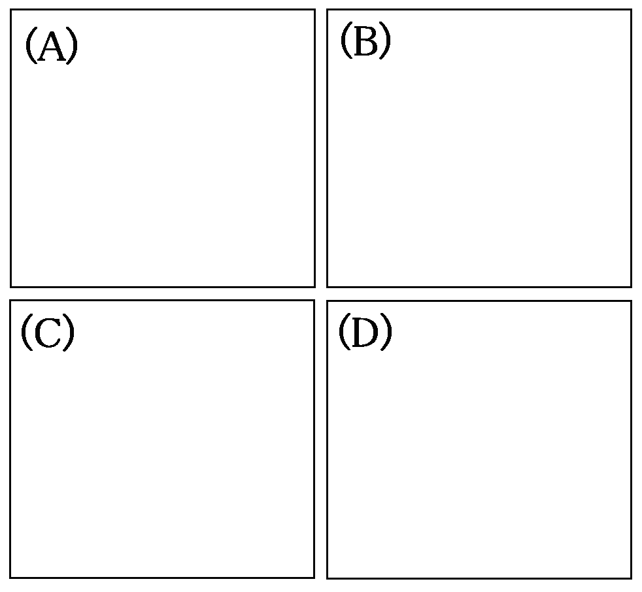
FIG. 1. XRD profiles of clay minerals in sample A.

TABLE 1. Chemistry of clay minerals.
 | Sample A | Sample B | Sample C | Sample D
A  B  C  D | 15.25  22.55  56.22  11.28 | 13.25  52.52  13.72  31.25 | 18.26  0.57  10.25  0.11 | 39.01  89.92  22.38  5.45

（Please do not use vertical lines in tables）

